Project Report
UCD assessment Introductory Data Analytics
Bea Kiebat

GitHub URL
https://github.com/bkiebat/Assignment

Abstract
Short overview of the entire project and features

Assessment for the Certificate of Introductory Data Analytics course by UCD Professional Academy based on English Premier League, League Cup, FA Cup and Champions League football to show my understanding of the content of the course including Introduction to Python, Intermediate Python, Introduction to Importing Data in Python, Intermediate Importing Data in Python, Data Manipulation with Pandas, Joining Data with Pandas, Introduction to Data Visualization with Matplotlib and Data Visualization with Seaborn

Introduction
Explain why you chose this project use case

Having a great interest and love for football in general and Liverpool FC in particular, it was clear from the beginning that I wanted to work on football and LFC data. The most important pieces of data in football are goals scored (obviously for your own team) and as a Liverpool-fan I’m in the lucky position that not only our famous, original “front 3” keep hitting the opposition net, but both new strikers and “benched, old favourites” alike use “secondary competitions” like the two domestic cups to make their mark on the pitch – as well as in my datasets.

Dataset
Provide a description of your dataset and source. Also justify why you chose this source

I used 4 different data sets, using several sources to combine files, information and content in order to work on this project.
The sources I took the data sets from are
- “Kaggle” for the file ‘Premier League players values 2021’
  - “Kaggle” has a huge data set, freely available for pretty much every subject
- “Anfield online” for the file ‘Liverpool FC Stats 2021 – 2022’
  - As I wanted to focus on LFC, the best place to find specific LFC data
- “BBC Sports” for a file on Champions League Top scorers
  - For a scrapping example
- Own data file
  - Put together previously with information from LFC homepage, Fantasy Premier League and match days

Implementation Process
Describe your entire process in detail

I started by importing all relevant libraries, like pandas, matplotlib.pyplot, requests, seaborn, nympy so I could work with the various codes.

I then imported my first data set "Liverpool FC Stats 2021 - 22.xlsx" which I downloaded from the LFC website and named it ‘goal_stats’.

I subsequently deleted the first row after the header as there was no value in it.

Then I imported a 2nd file "Premier league players values 2021.csv" from the Kaggle website. I was satisfied that both files were in a different format (Excel and csv), so I could show that it doesn’t matter what format the source file is in. I named this 2nd file ‘players’. It is a much bigger file as it includes all players of all Premier League clubs of this season – which is season 2021 / 2022.

Due to the fact that the names in both files were written in different cases I made the decision to change them both to upper cases to have a common value on both files. Earlier I had added a column ‘Club’ to the "Liverpool FC Stats 2021 - 22.xlsx" file. As this data came from the LFC website, there obviously was no such column in the file.

In order to have another common value on both files I also decided to change the column ‘player’ from the Premier League file in to ‘PLAYER’ like on the LFC file to merge the files with an inner join and called the combined file ‘liv_stats’.

I used a few codes to show some detailed information in the new file;
- index – which gives you a count of the information in the file
- describe – which shows some statistics of the file

I then stripped the file to a smaller table by returning multiple columns: Player, Position, Foot and Match Time. The total of this table is 570 rows by 4 columns, but Jupyter only shows the first and the last 5 rows of a table plus the header of the table.
Some more information is shown by dtypes – which gives you the layout of the array.

Because I was mainly interested in the Liverpool players, I dropped all lines on the combined file that did not have an LFC player in it. I also sliced the file to only come back with Liverpool info and filtered it too. There is often more than only one way to come to the same result. This (filtered) file I then named ‘club_stats’.

I wanted to play around with some more codes, so I made the decision to sort the table by players’ names in alphabetical order.

#Scraping a table
I used another football related file here, which is Champions League top scorers from the ‘BBC Sports’ website. I ran it to check if everything was fine and got the ‘Response 200’ – which indicates that the input is OK.
I then moved on to iterrows - to see the index and row from each line of a DataFrame. However, I restricted it here to the first 2 players on the ‘goal_stats’ table: van Dijk and Becker and showed the index – information on both players from that table like appearances, goals, match time, cards received etc.
After that, I wrote some user defined functions (definition: “they take some input (arguments), run some code (body), and then return a value” – source: https://stackoverflow.com/) again based on LFC data and my file ‘goal_stats’.
I created a list ‘goalies’ with name and height of the LFC goalkeepers .
I then showed 2 different ways of getting help within the Jupyter Notebook by using 2 different codes.
- using the question mark (?) in front of the code brings you a pop out window with the explanation (I copy/paste ’ed it into the Notebook)
- using the word ‘help’ in front of the code – however with round brackets in this case () – brings the explanation up in the line below your code.
The last part of the project is #Visualisation
I used several methods and codes as well as data in order to show the multiplicity of different graphs. Depending on what needs to be highlighted, there is a graph for every type.
The first graph was very confusing, ‘busy’ and not conclusive at all because there was way too much data in it.
I then tried to show more detailed information using the ‘less is more’ philosophy.

Results
Include the charts and describe them

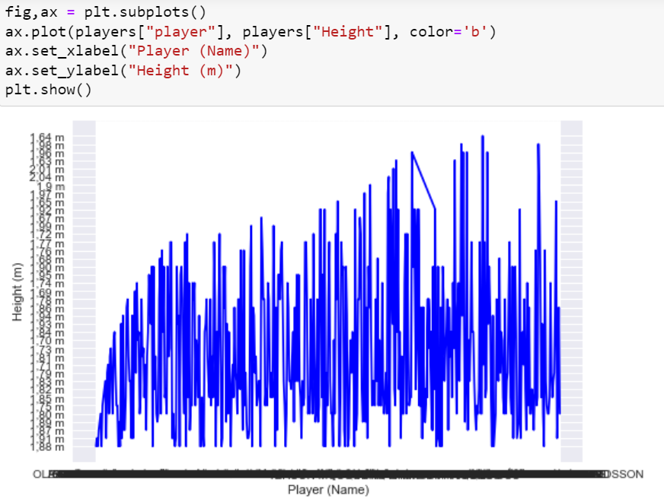
In this chart I wanted to show the size of the players. However, as the data in the table is too detailed (height by cm) and it is the table of the current players of the Premier League (20 clubs) the graph does not give any conclusive picture but rather looks like a lie detector graph or an ECG of a very anxious person.

~~~

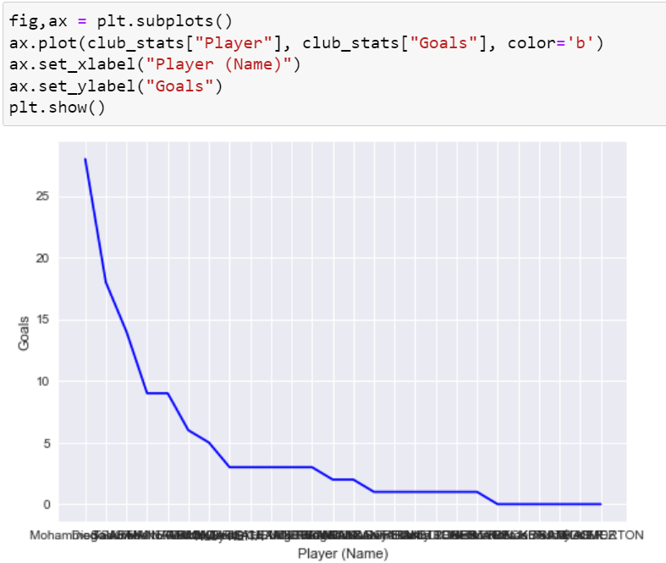

Here I wanted to see who scored how many goals; again, based on the LFC data. As the names overlapped on the x axis, I rotated the names, so the graph was easier to read:
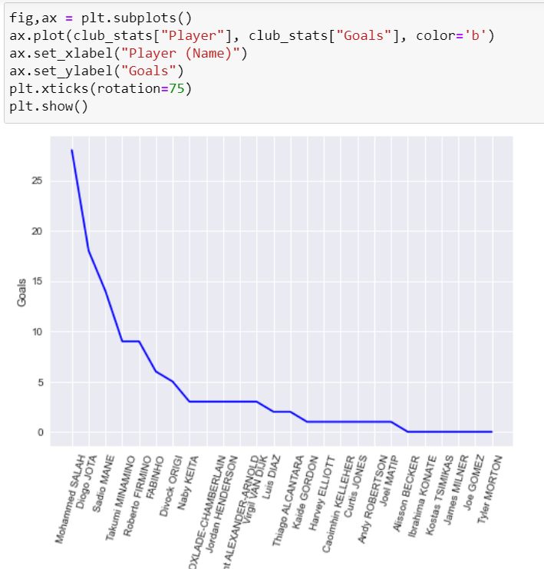

~~~

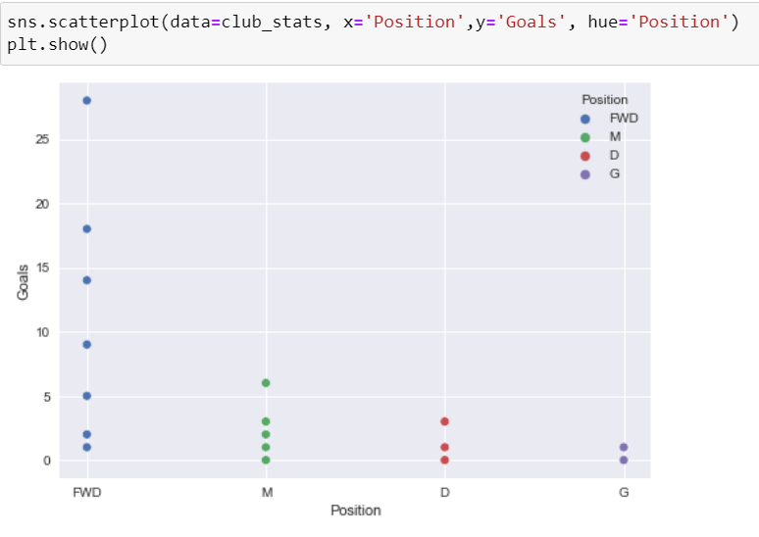

In this graph I am showing the goals scored not by players but by the different positions of the players. What I initially found surprising is that there is not too much difference between midfielders and defenders. But then again, central defenders tend to move into the opposition box for corners on a regular basis to attempt a headed goal. And the LFC left- and right-backs are the most offensive players in their respectable position not only in the Premier League, but also in the Champions League. So, I can’t be too surprised after all.

~~~

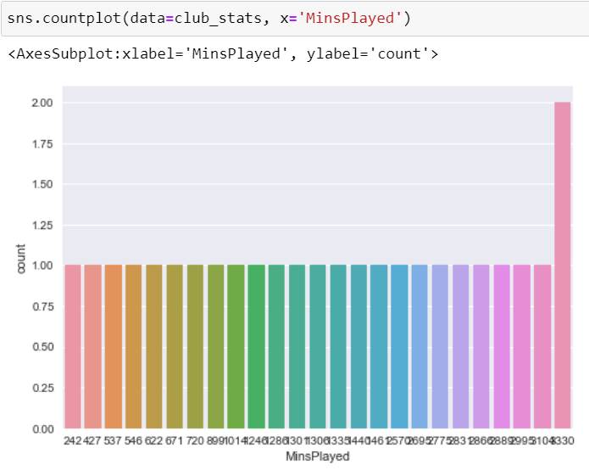
Another bad example for too detailed data for this kind of graph. To show the goals by minutes played I later used a different plot.

~~~

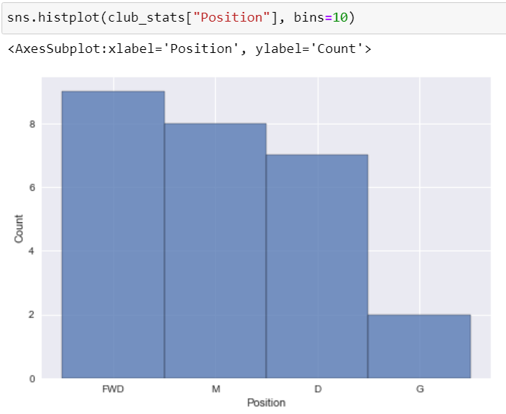
There are more plots and graphs coming to show the variety of visualisation types and what can and cannot be read out of them. Here I used another way to show the goals by position.

~~~

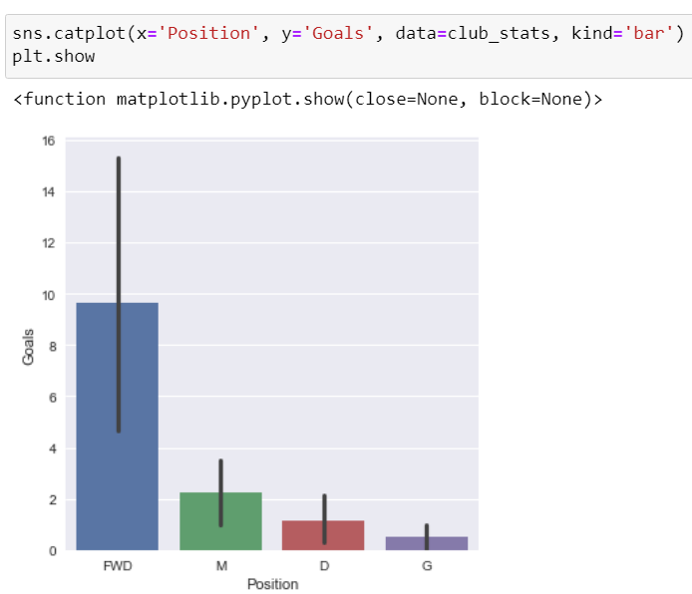
With and then without confidence (presumption calculated from the stats of the table) – as it is not needed here.

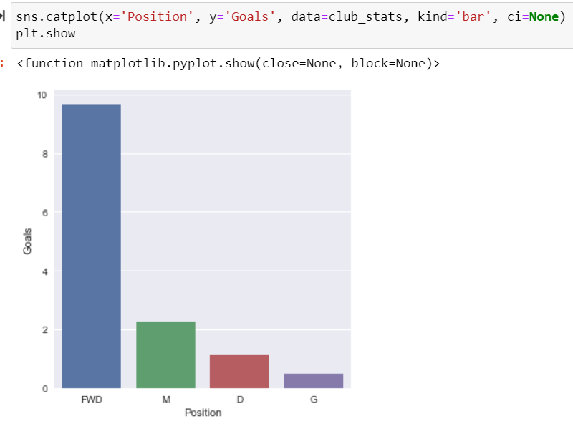

~~~

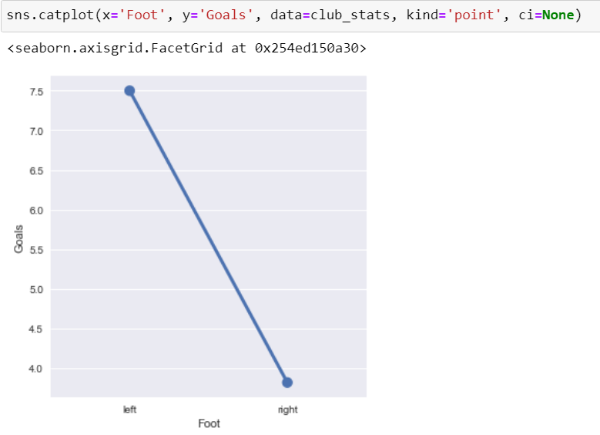
Here we can see how many goals have been scored with which foot.

~~~

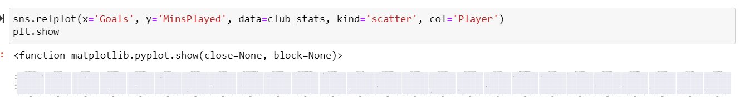
26 plots to compare scored goals by minutes played per player.

~~~

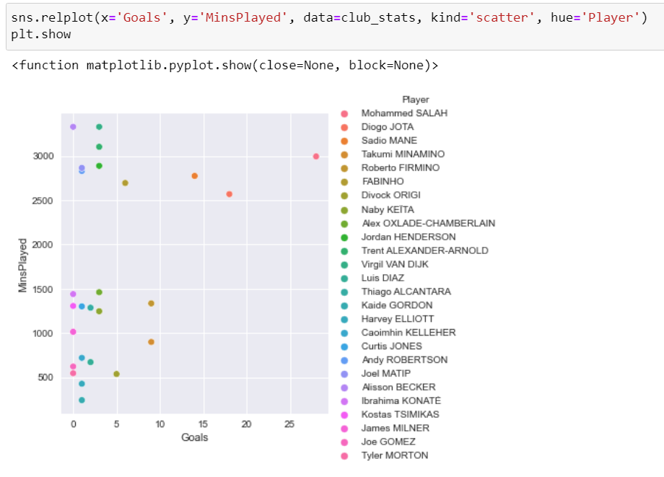

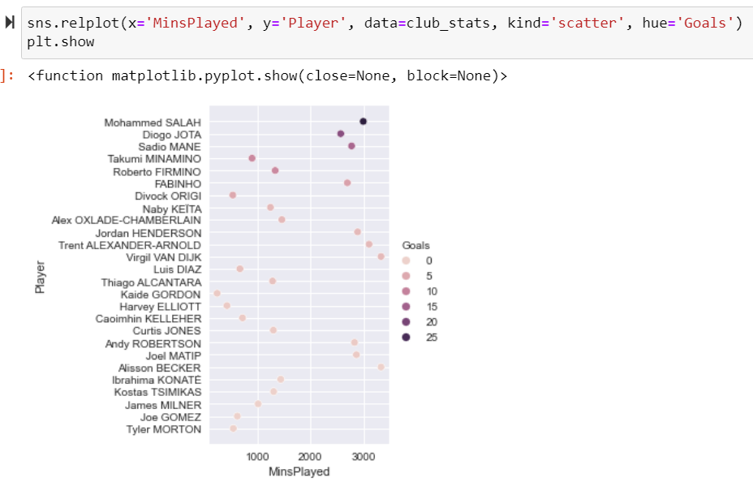
In these two plots you can see the goals by mins played allocated to the names of the players by different colours in 2 different versions.

~~~

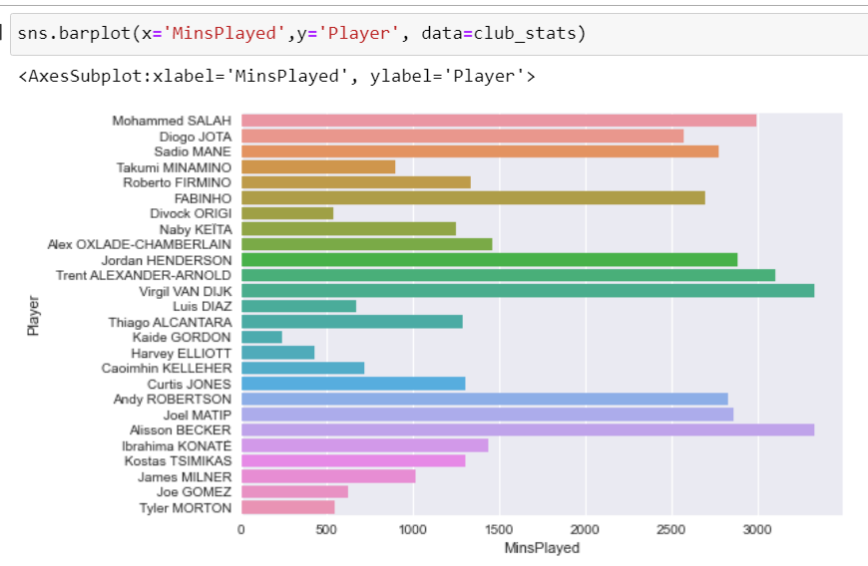
This plot shows the time the LFC players were on the pitch in total during the current season.

~~~

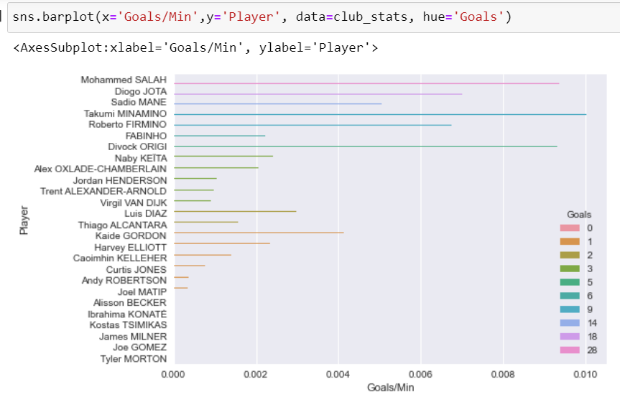
This plot shows the goals scored by LFC players by time played – which shows a different top scorer than by overall goals in general.

~~~

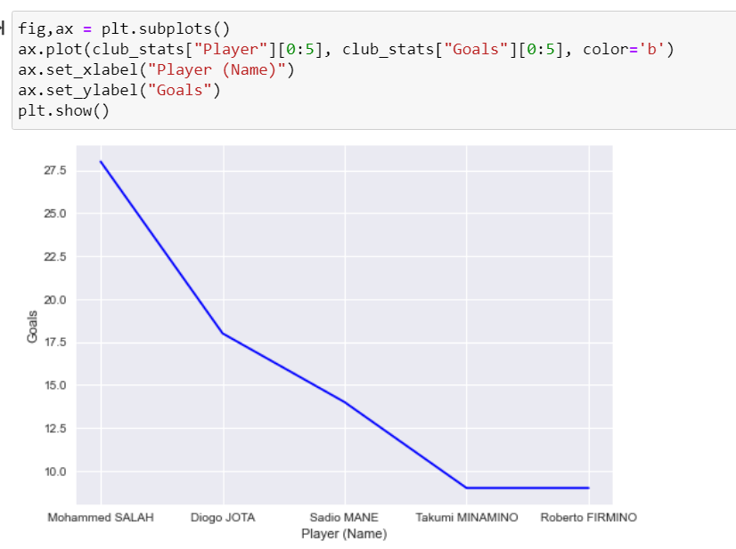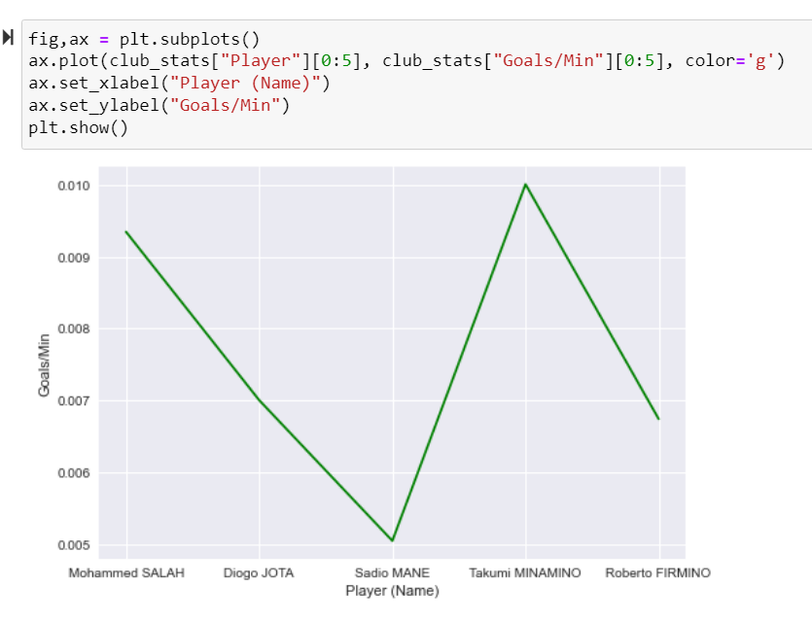
I then focused on the top 5 scorers for LFC this season and showed on these 2 plots the different outcome again for goals in total and goals by minutes played.
~~~

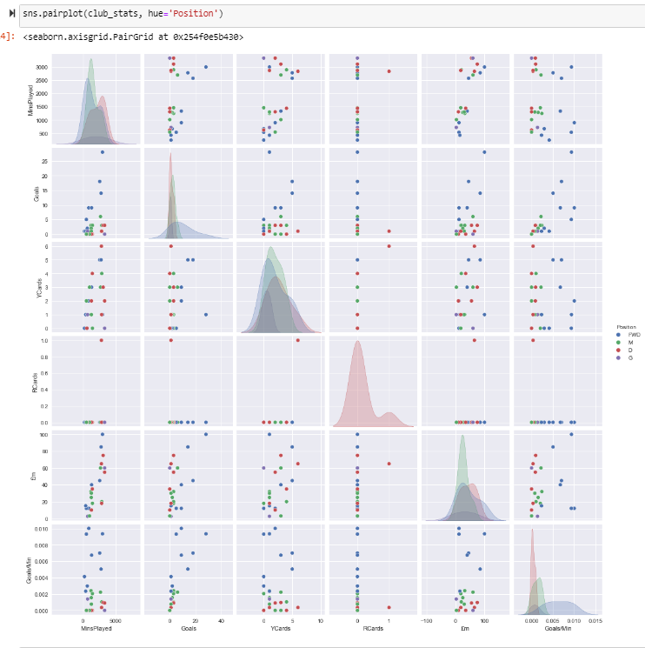
To finish I used a pair plot to show the most information in one picture with different focus in each plot and the relation between them.

Insights
Point out at least 5 insights in bullet points

- Mo Sallah is the overall top scorer for LFC this season so far
- Takumi Minamino however is the top goal scorer by minutes played / goal ratio for Liverpool
- The Liverpool players with the most minutes played as of now are Allison Becker (goalie) and Virgil van Dijk (defence)
- Robert Lewandowski from Bayern Munich is the top scorer in the Champions League this season so far with 12 goals (meaning 1.55 goals per 90 mins) and a shot accuracy of 68%
- Twice as many goals are scored by left feet than right feet – at least by LFC players
References
Include any reference
https://www.kaggle.com/datasets - Find Open Datasets and Machine Learning Projects | Kaggle
https://www.anfield-online.co.uk/ - Anfield Online - Liverpool FC website
https://www.liverpoolfc.com/ - Liverpool FC - Homepage
https://www.bbc.com/sport - BBC homepage
https://www.bbc.com/sport/football/champions-league/top-scorers
https://fantasy.premierleague.com/ - Fantasy Premier League, Official Fantasy Football Game of the English Premier League

